**Ayesha Zubair**

**52916**

**OS Lab 7**

**Task 1**: Read the contents of file1.txt and create file2.txt with the same content using redirection only in a single command.

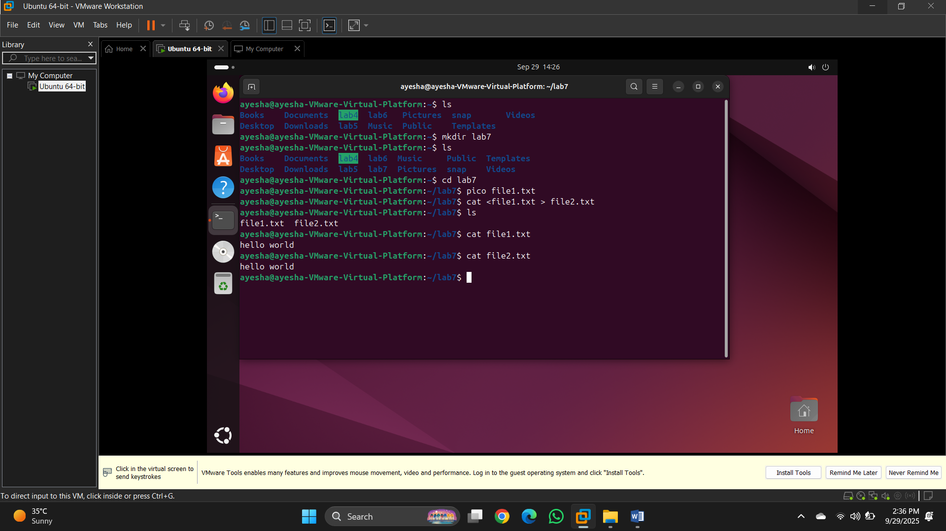

**Task 2**: Run date and append the result to a file named dates.log every time you execute the command.

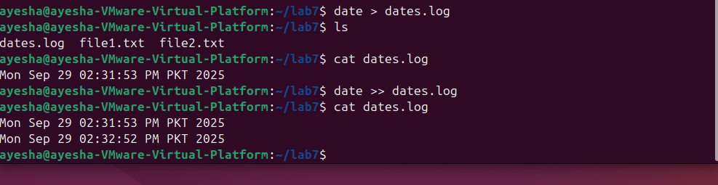

**Task 3**: Run a command that will produce both valid output and an error. Redirect standard output to ok.txt and errors to err.txt.

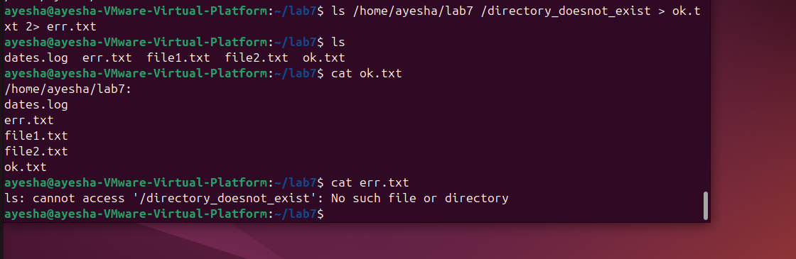

**Task 4**: List the contents of the /bin directory and also try to list a non-existent directory /no_such_dir and redirect **both** the normal output and the error messages to be saved together in a single file called all.log in one line.

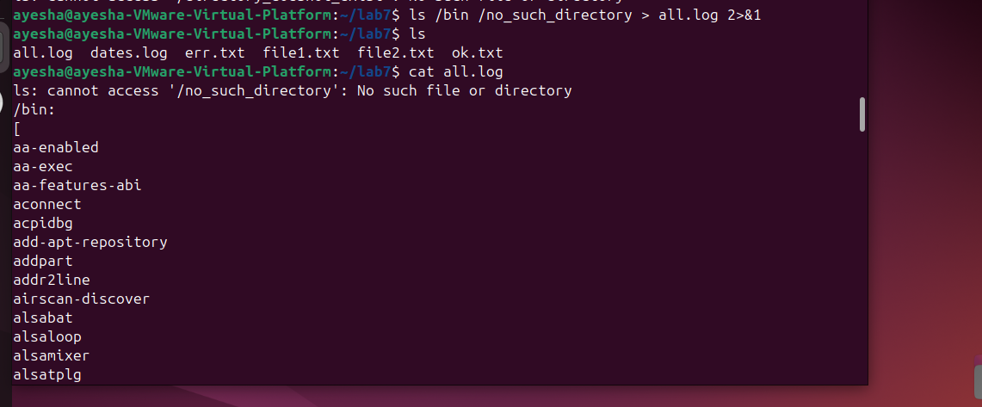

**Task 5:** Run a command that reads from input.txt and writes sorted, unique lines into unique.txt using pipe operator.

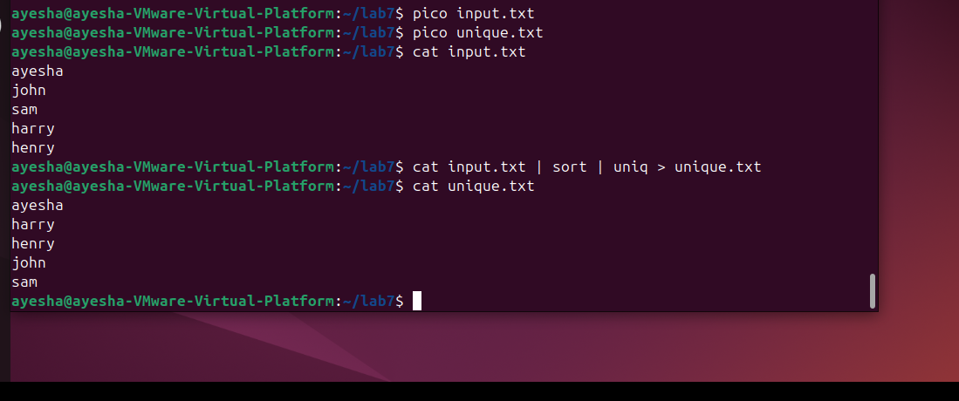

**Task 6:**

What would be the result of the following commands.

* **cat filename > new // filename is name of file that exist at current path**

Copies the contents of filename to new. If new doesn’t exist, it creates new and then copies its data.

content

* **who > new**

This commands writes the users to new. If new doesn’t exist, it creates the file.

If new has some content, it overwrites.

* **ls | sort –r**

Sorts the files in reverse order.

* **ls | sort -r >> new**

Sorts all the files in reverse order and sends data to new, if new doesn’t exist, it creates the file.

If new has some content, it overwrites.

**Task 7:** Sorts the contents of **fruits.txt** in alphabetical order. Filters the sorted output to only display fruits that contain the substring "ap".

